# Website Plan

Business or Brand Name: Lara Hilgenhold Photography

Description: website designed to showcase my photography and accept client inquiries.

## Website Goals

1. Gain traffic from potential clients so they can see my work
2. Have my first client inquiry from my website by spring of 2026
3. Have a photoshoot set up from an inquiry through the website by 2027

## Purpose Statement

The purpose of this website is to allow potential clients to browse my work and reach out to communicate for potential photoshoot opportunities to grow as a photographer.

Market Research

1. Katie Wilson Photography - <https://www.katiewilsonphoto.com/>

* I like that the main color of the site is a soft, warm toned gray with white sections throughout. This color is easy on the eyes and the contrast of the white boxes and banners in certain parts is pleasing to the site user. I also like how this looks with the brown lettering throughout the site. The sessions page on this website also has a guide as to what the steps of the
* This photographer’s site does not have direct navigation to a gallery. At first, I thought that this site did not have a gallery but I later found it under the “sessions” tab, where it had a list of services offered and you could click on each service and it would direct you to a gallery for that service. I like the idea of having the galleries sorted by service type, but this site could benefit from direct navigation to the gallery.

1. Jen Jacobowitz Photography -

<https://jenjacobowitz.com/>

* I like the blog page on this website. I feel like it allows users to not only find more information they also help the user get to know the photographer and a better understanding of what to expect from certain session types.
* I like the “client closet” idea but I am not fond of the execution on this site. The pictures are too large to see the whole thing on the screen at once and I feel that the pictures also cycle a little too fast, with no “back” or “next” buttons to allow clients to view at their own pace.

1. Christian Rumley Photography - <https://christianrumleyphotography.com/>

* I like that the photos on the homepage are cohesive and clearly define the style of this photographer. The style of the homepage matches this photographer’s style very well and complements her work in a very pleasing way. I love the minimalist flowers throughout the page as well. They help fill some space but still allow for some white space plus it complements the overall aesthetic of the page.
* Some of the font sizing on this page is too small, which may make it difficult for some users. The typography of the logo on top of the image at the very top may be difficult to read for some users. I would change the small font sizes to be a bit bigger to ensure that most users can easily read the information on the page.

# Target Audience

**Business or Brand Name:** Lara Hilgenhold Photography

**Description:** Website for Lara Hilgenhold Photography.

## Characteristics

Average Age/Range: 18-50, any for family portraits

Education level: all

Median income: any (this will change as I become more established as a photographer, as the amount I can charge will increase over time)

Race: all

Ethnicity: all

Gender: all

Primary spoken language: English

Unifying characteristics: Family for family portraits, new baby for newborn photography.

Target audience will likely change overtime as I find my niche as a photographer. As for now, any experience is welcome and therefore the more audiences I can reach, the better.

Mobile View Mock-Ups

Page 1: Home page for Lara Hilgenhold Photography

* Website Banner
* 3 line “hamburger” style navigation menu
  + Click to show navigation options
* Links to social medias
* About me section
* Bottom Banner

Page 2: Contact Info for Lara Hilgenhold Photography

* Website Banner with navigation menu and social media links
* Session Inquiry form
* Contact Info
* Bottom banner

Page 3: F.A.Q. Page for Lara Hilgenhold Photography

* Website Banner
* FAQ bubbles
* Email for questions not answered by FAQ page
* Bottom Banner

Page 4: Services Offered Page for Lara Hilgenhold Photography

* Website Banner
* List of Services
* Scrolling Gallery
* Link to Full Gallery
* Bottom Banner

Page 5: Gallery Navigation Page

* Website Banner
* Gallery type buttons
  + These buttons will take the user to another page that contains a gallery layout for that type of photography
* Bottom Banner

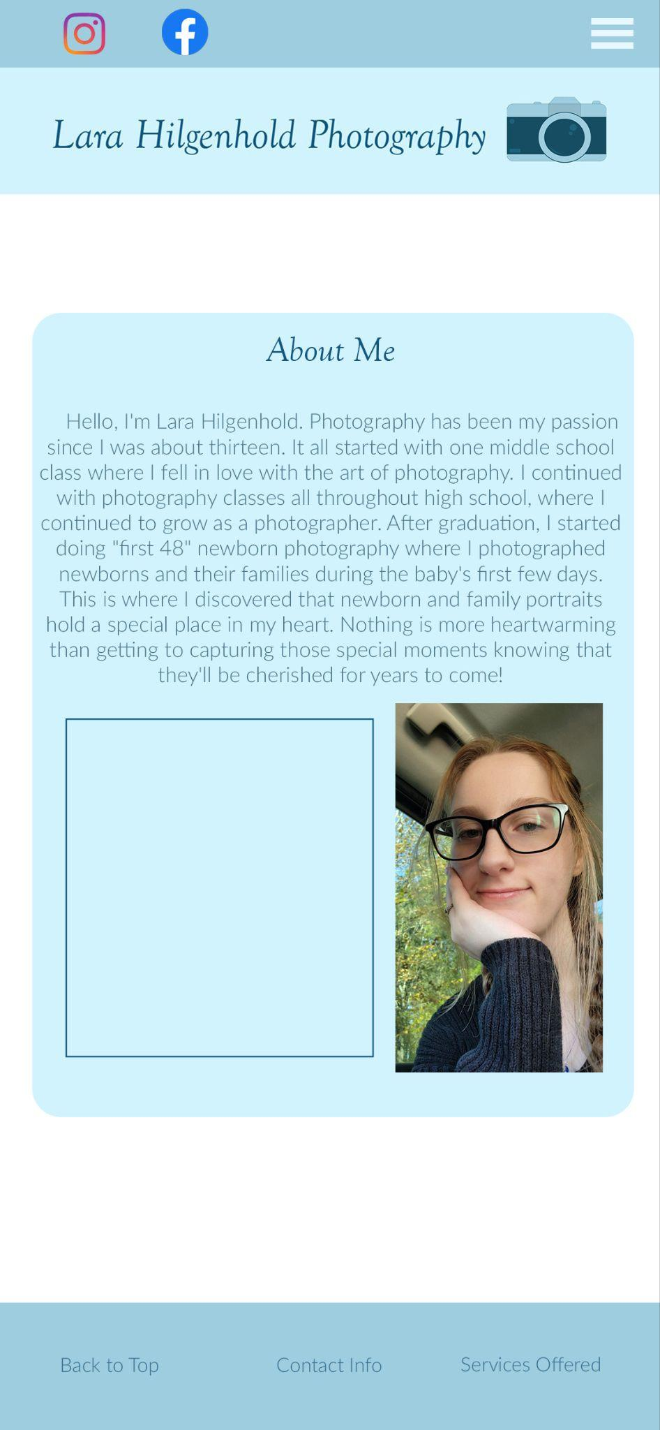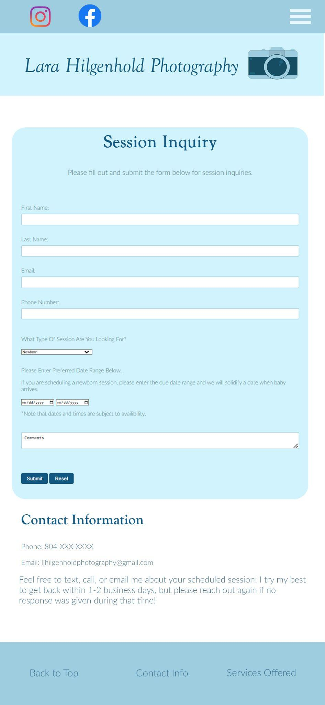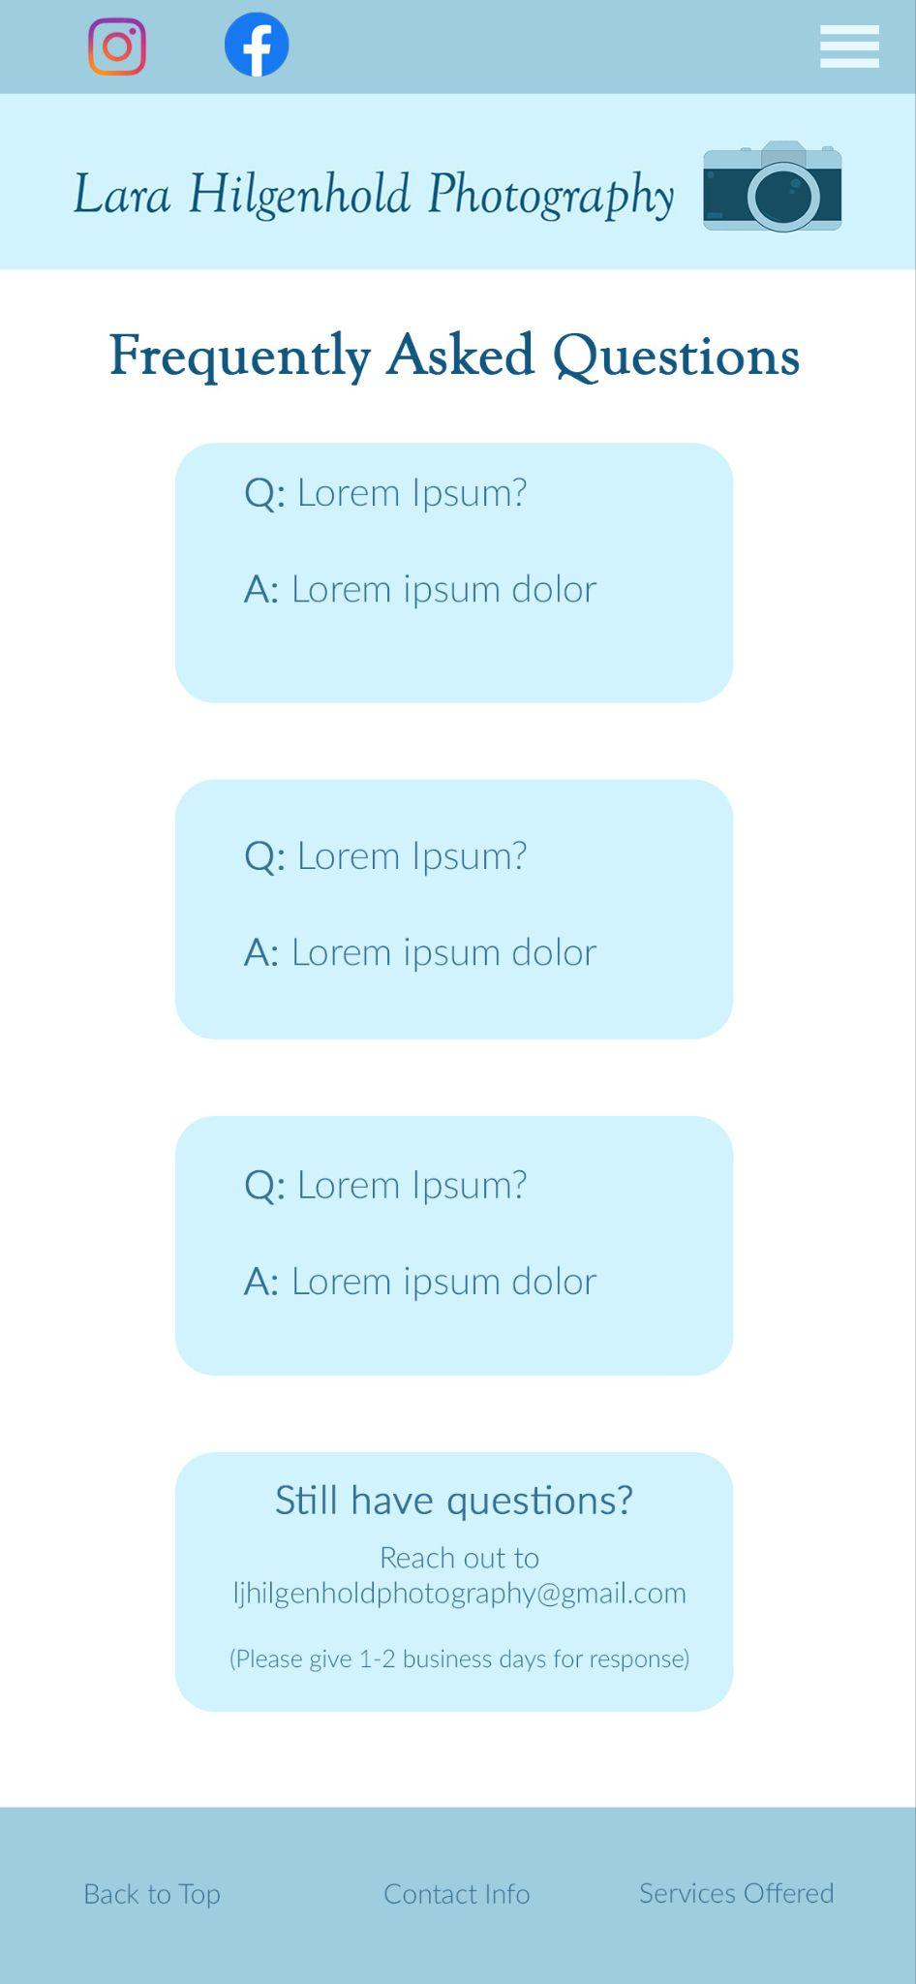

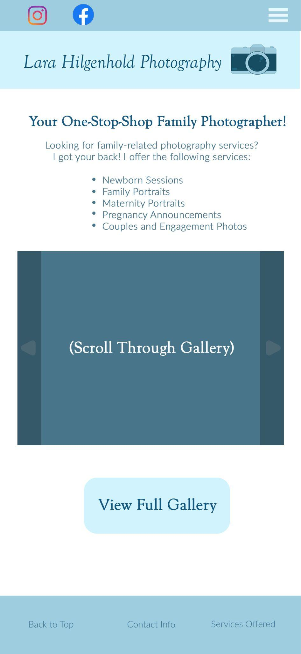

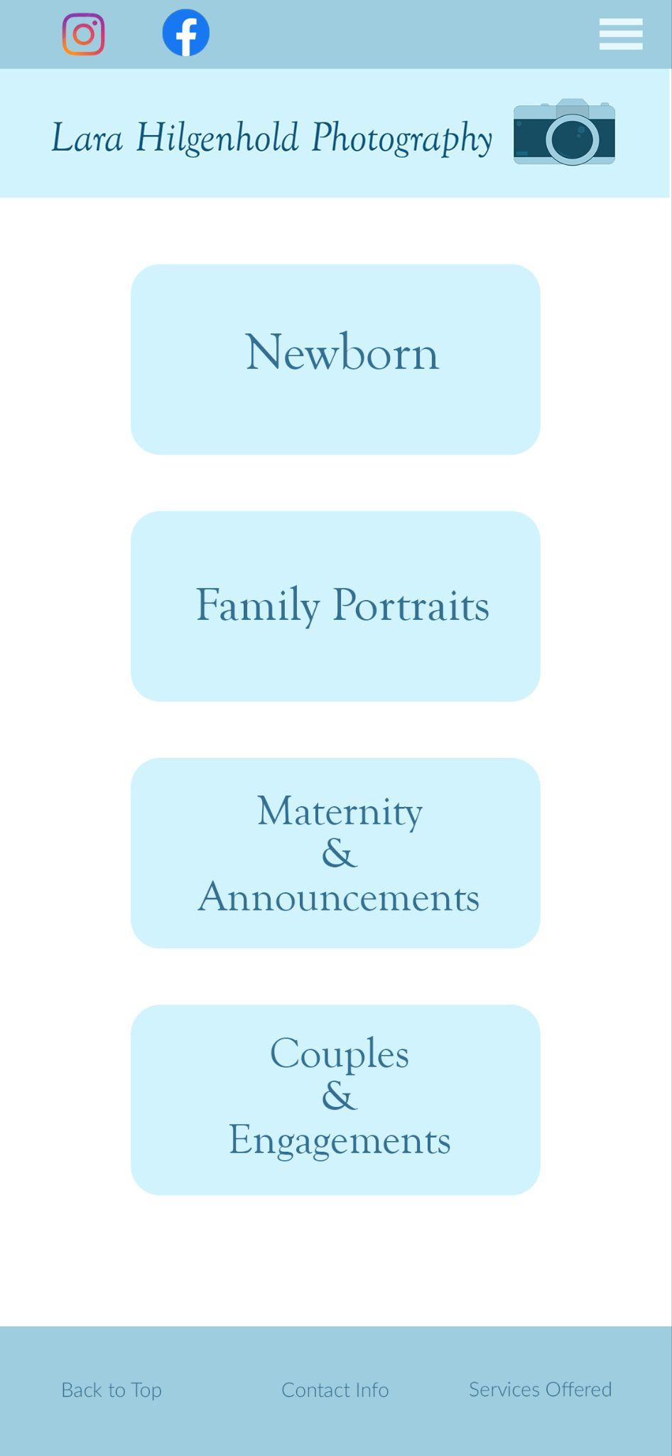

Desktop Mockup

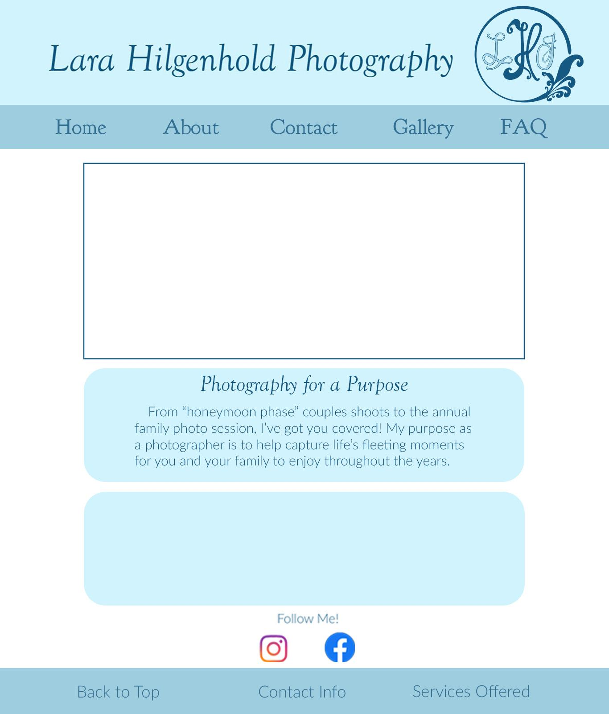

Information Architecture and Site Map

Lara Hilgenhold Photography

**About**

* Photographer statement/about me
* About me supporting image
* Areas served

**List of services offered (each linking to corresponding gallery)**

* Newborn
* Family
* couples/engagements
* maternity/pregnancy announcements

**Gallery**

* 4 different sections for different photography types
* Each type has its own scrolling gallery

**Files**

* Examples of my work (currently represented by my own photos of flowers and landscapes) eventually replaced with:
  + Newborn
  + Family
  + couples/engagements
  + maternity photos/pregnancy announcements

**Contact information and Booking**

* Email
* Social media handles
* Phone
* Session type interested in
* Date range

1. About
2. Photographer statement/about me
3. About me picture
4. Areas served
5. Image Link to gallery
6. Image link to booking
7. Services Available
8. Newborn
   1. Link to newborn section of gallery
9. Family
   1. Link to family portrait section of gallery
10. couples/engagements
    1. Link to couples portraits section of gallery
11. maternity/pregnancy announcements
    1. Link to maternity section of gallery
12. Link to booking
13. Contact Information and Booking
14. Email
15. social media
16. Phone
17. Booking form

